Cherry Chase Charger Pride Expectations Grid
Area | Be Safe | Be Respectful | Be Responsible
All Common  Areas   | *Walk  *Keep hands, feet, and objects to self  *Use all equipment and materials appropriately | *Use kind words and  actions  *Be an Upstander  *Take proper care of all personal belongings and  school equipment | *Follow school  procedures  *Wait for your turn  *Clean up after self *Follow adult directions
Bathrooms   | *Open doors slowly  *Use, flush, wash, leave  *One student per stall  *Keep water in sink | *Use quiet voices  *Give people privacy  *Return to room  promptly | *Report any problems  *Wait outside for friends  *Use bathroom pass  *Dispose of trash
Halls  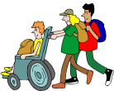 | *Face forward  *Stand behind the person in front of you  *Watch for opening  doors | *Walk quietly | *Stay in supervised areas  *Get where you’re going
Office   | *Walk/Enter quietly | *Wait your turn  *Use a quiet voice | *Have your yellow/ white/red slip
Drop Off/Pick Up  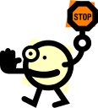 | *Use crosswalks  *Look both ways  *Use drop off zone  *Walk your scooters and bikes on campus | *Quick goodbyes  *Wait patiently for cars to move | *Be ready to exit car  *Walk to supervised areas
Library | *Follow library  routines/procedures | *Use quiet voices  *Listen to Mrs. Parnell | *Return library books on time  *Use shelf markers
Playground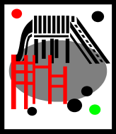 | *Stay on the grass/blacktop  *Walk on the blacktop unless playing an organized game  *Only climb on steps, ladders, and platforms  *Play safe games  *Eat in designated areas | *Share equipment  *Include everyone in games/play  *Set a good example (show your Charger Pride!)  *Play fairly  *No physical contact | *Be a problem solver / Upstander  *Keep personal toys/games/sports equipment at home  *Freeze when bell rings and wait for the whistle  *Sit by equipment basket and wait for an adult  *Return equipment when done  *Use office pass for any visit to office
Cafeteria  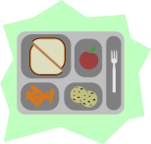 | *Be in a single file line  *Face forward  *Keep all food to self – no sharing | *Touch only your card and hold it quietly  *Use quiet voices  *Raise hands  *Use proper table  manners  *Listen to noon aides | *Eat your lunch  *Choose food and get all utensils quickly  *Clean up messes  *Pick up around your area

